**Assignment -4**

| Student Name | Sanjith M |
| --- | --- |
| Student Roll Number | 737819CSR173 |
| Maximum Marks | 2 Marks |

**Question-1:**

Pull an image from the docker hub and run it in the docker playground

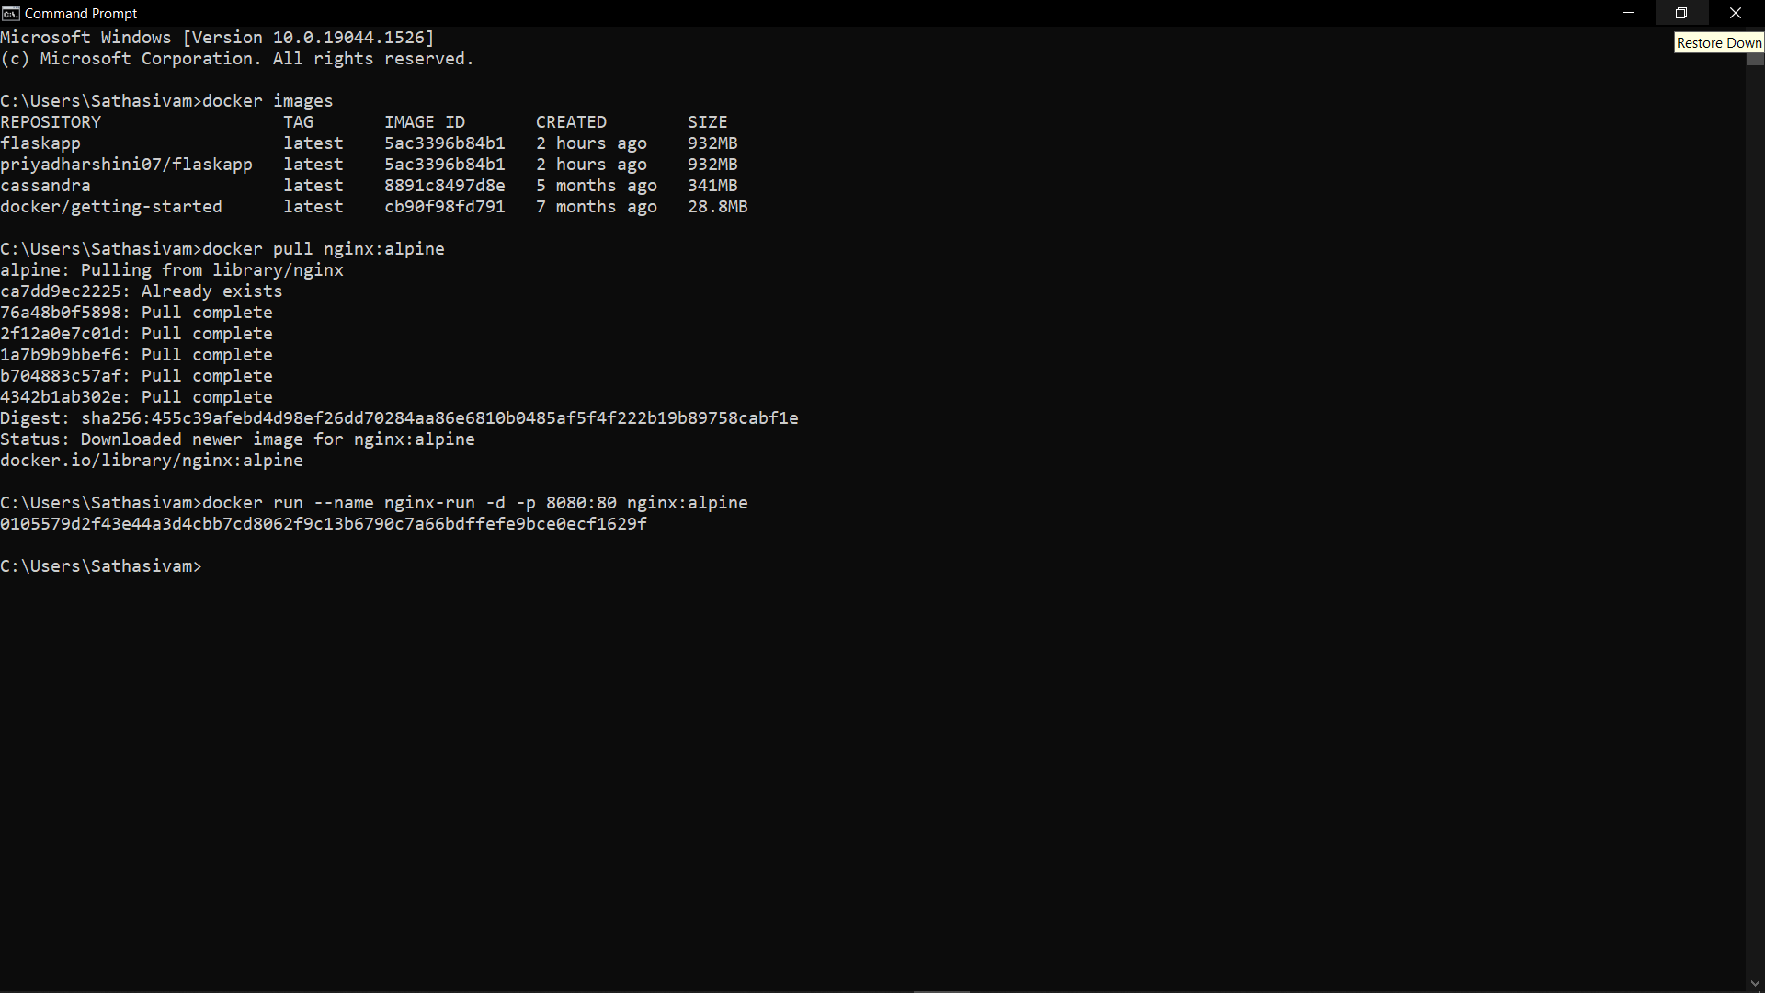

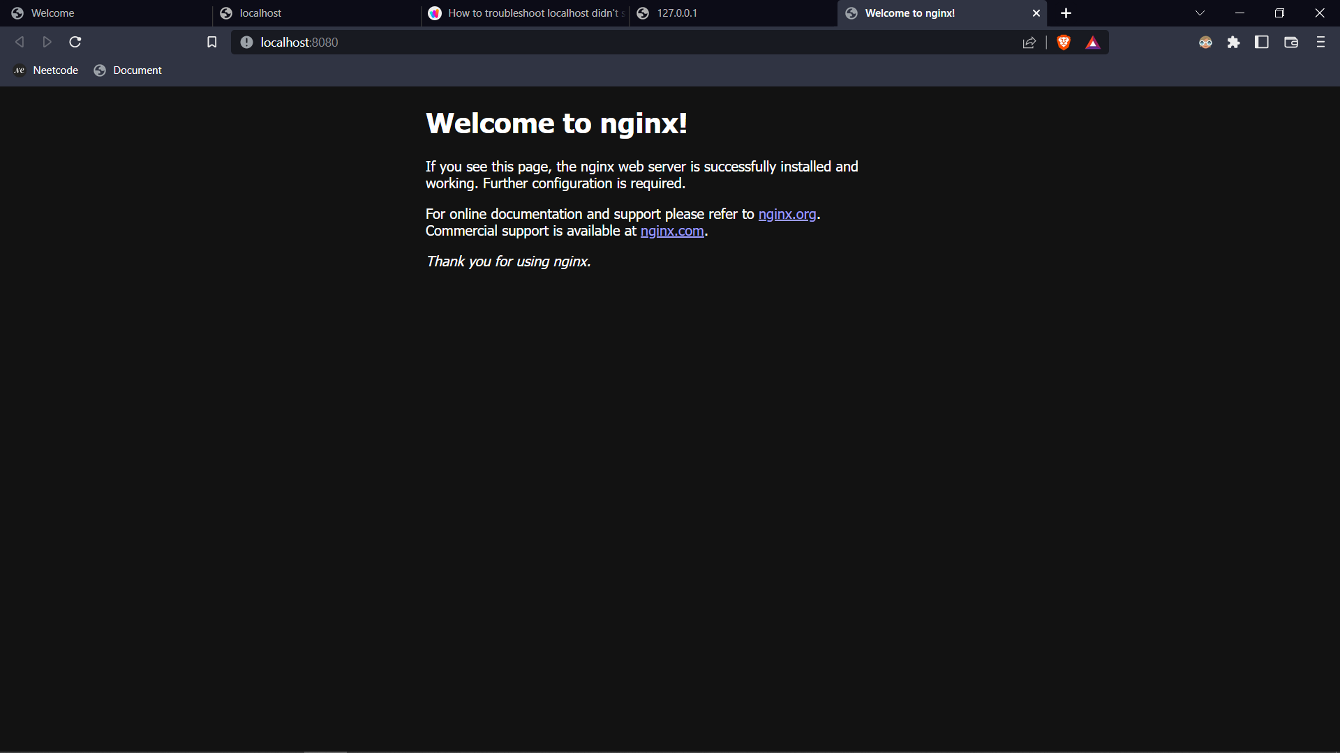

**Question 2:**

Create a docker file for the helloworld or job portal application and deploy it in docker desktop

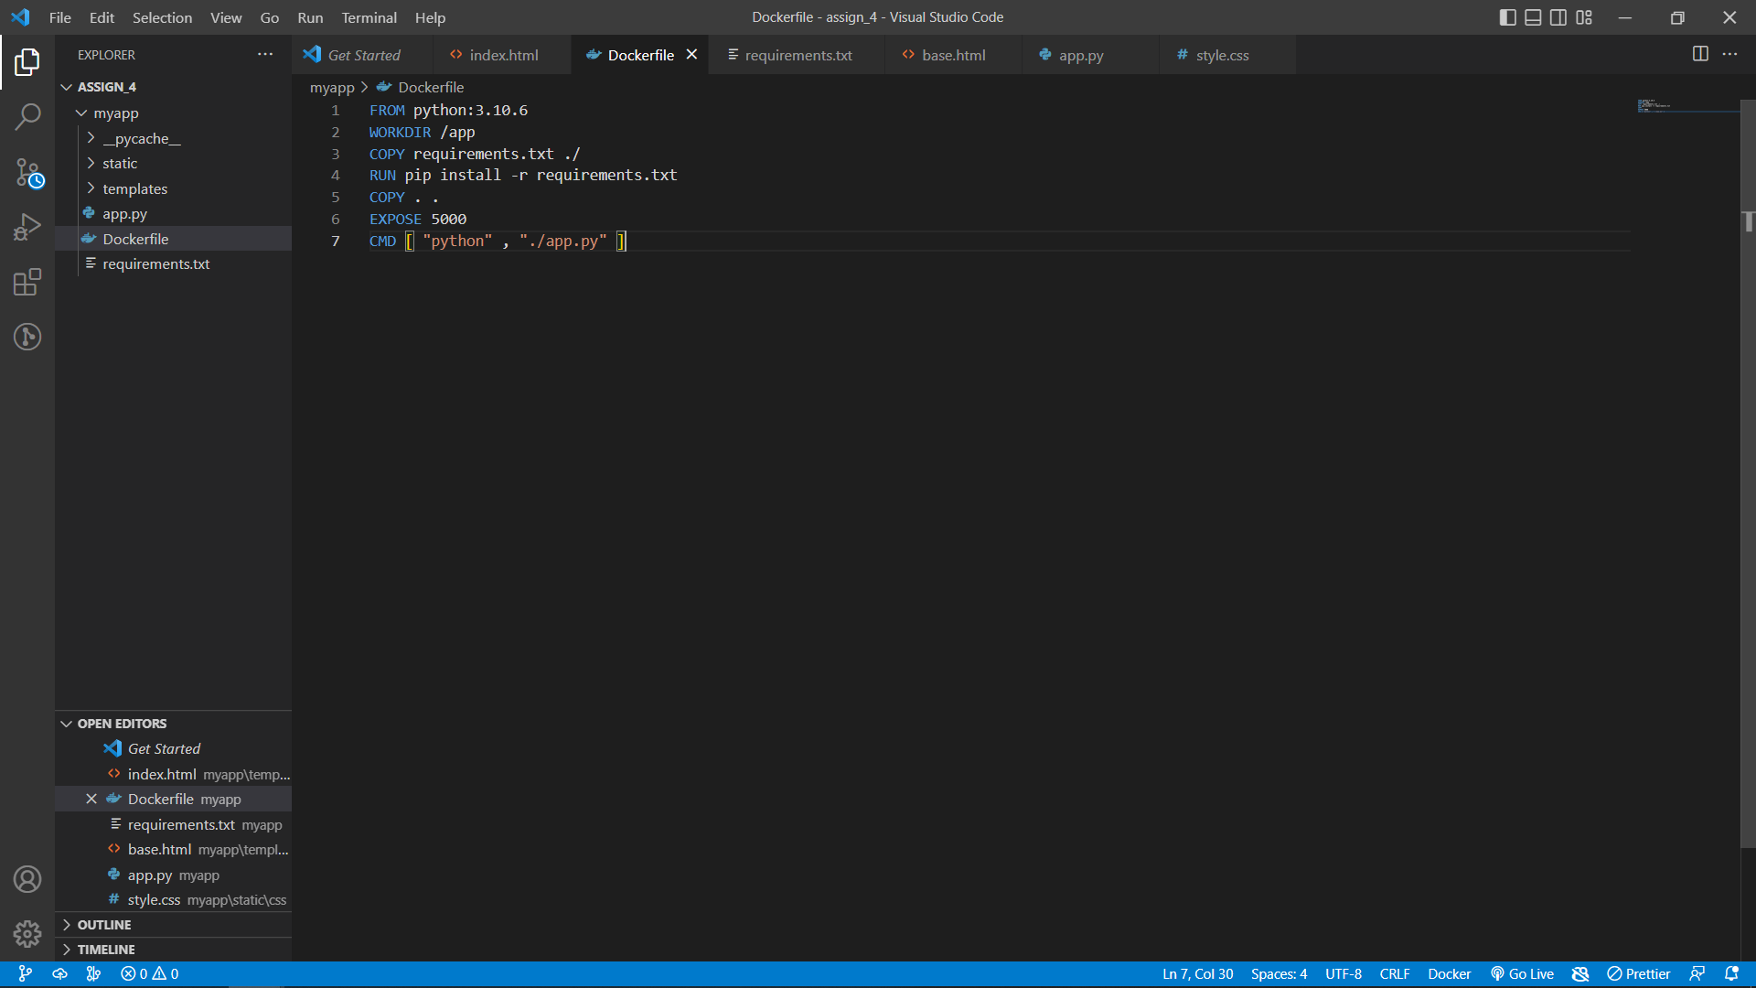

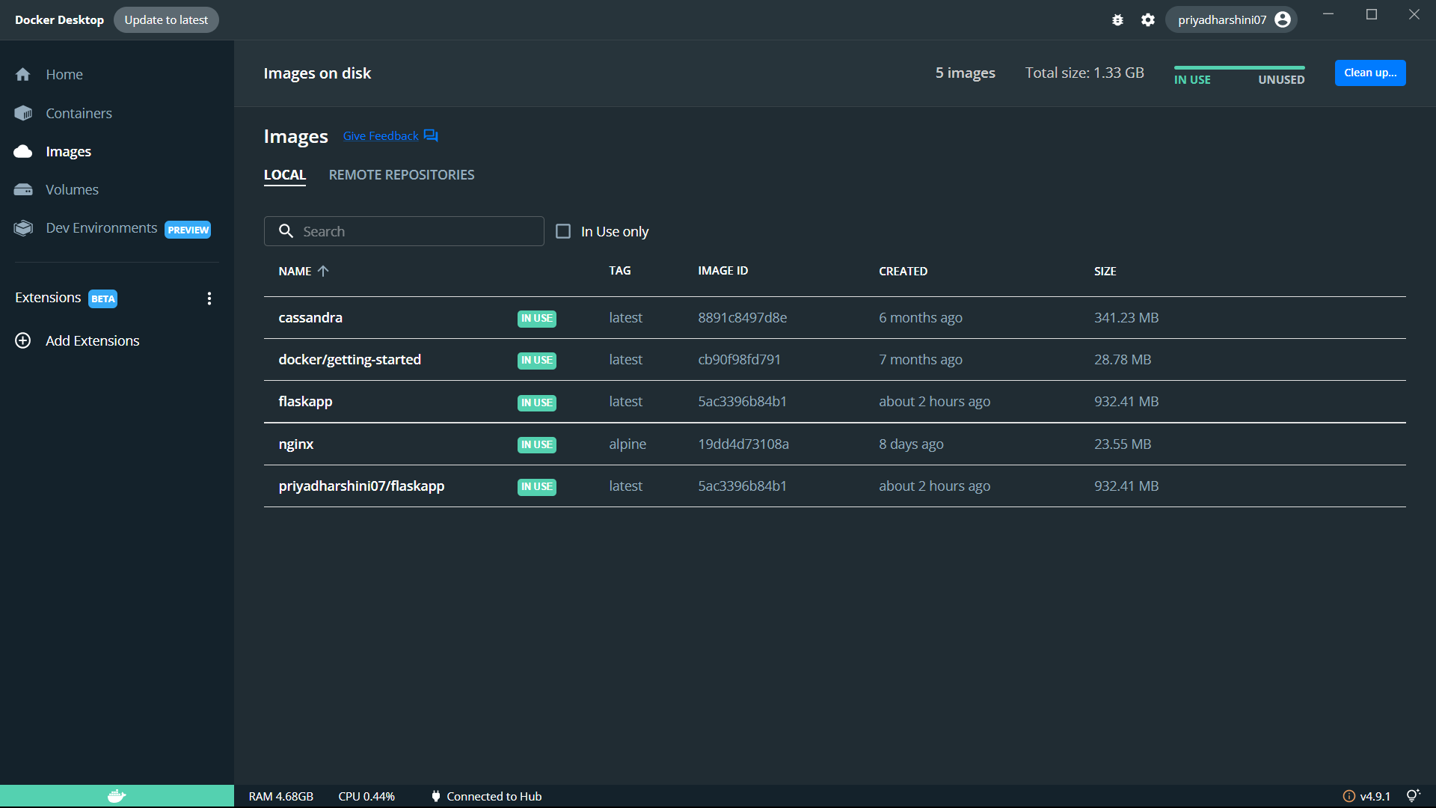

**Question 3:**

Create a IBM container registry and deploy helloworld app or jobportalapp.

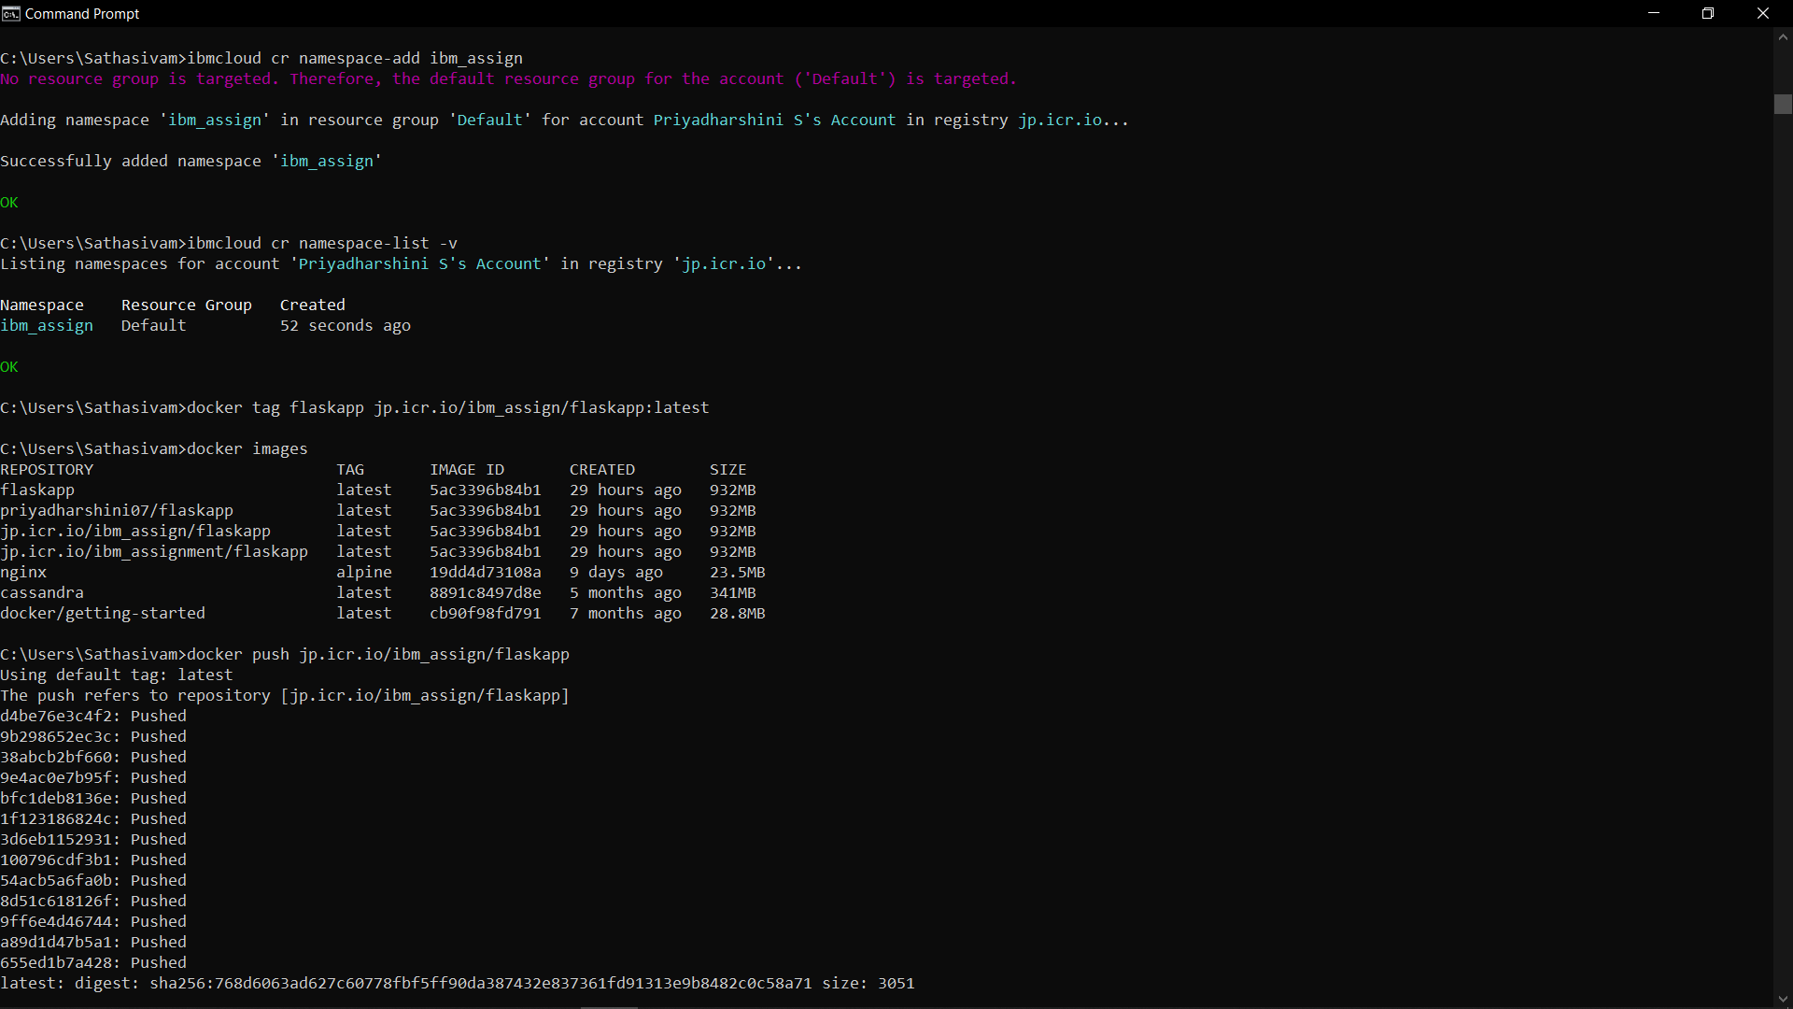

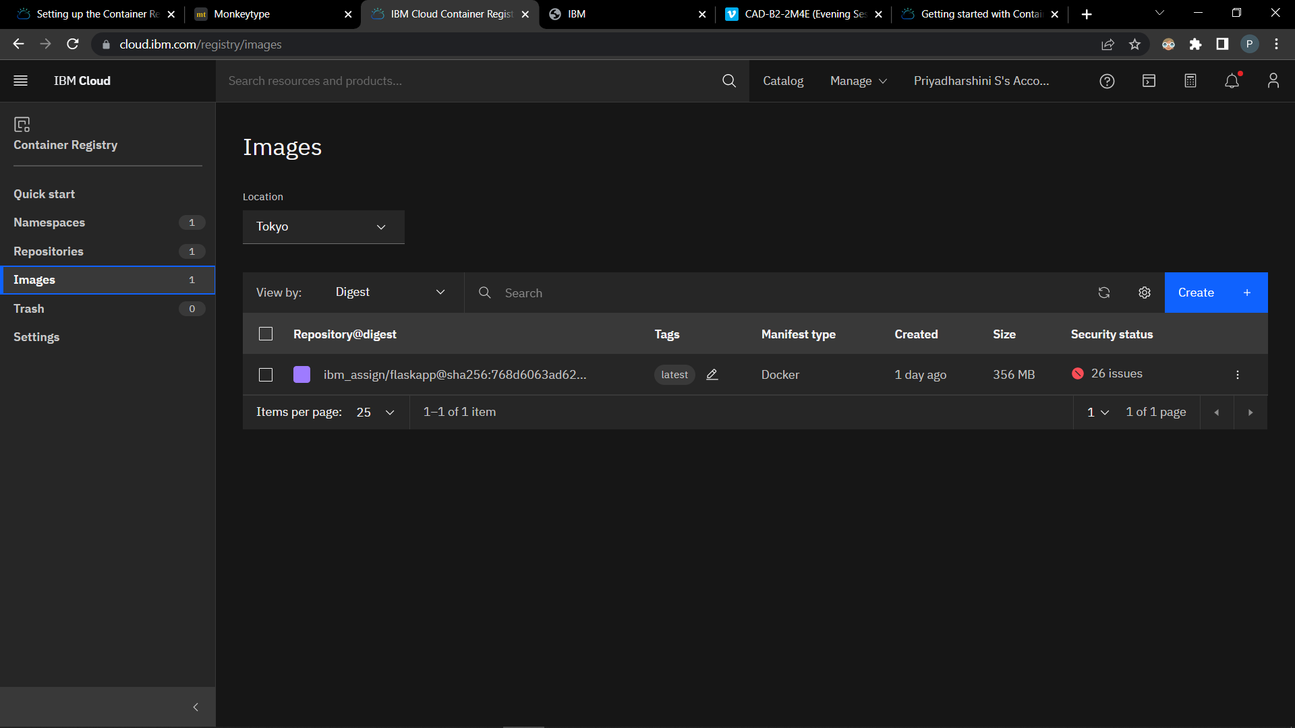

**Question 4:**

Create a Kubernetes cluster in IBM cloud and deploy helloworld image or jobportal image and also expose the same app to run in nodeport.

